**PACKAGE FOR TESTING PRIMARY SCHOOL PUPILS ON BASIC ARITHMETIC OPERATIONS**

**(Case study: Demonstration Staff School, Federal Polytechnic, Mubi)**

# TITLE PAGE

**BY**

**ISA YAHAYA A**

**(ST/CS/ND/23/086)**

**ISA MOHAMMED INDE**

**(ST/CS/ND/23/089)**

**DEPARTMENT OF COMPUTER SCIENCE,**

**SCHOOL OF SCIENCE AND TECHNOLOGY,**

**FEDERAL POLYTECHNIC, MUBI, ADAMAWA STATE.**

**IN PARTIAL FULFILLMENT OF THE REQUIREMENT FOR THE AWARD OF NATIONAL DIPLOMA (ND) IN COMPUTER SCIENCE.**

**JULY, 2025**

# DECLARATION

We hereby declare that the work in this project titled “**Package for Testing Primary School Pupils on Basic Arithmetic Operations (Case study: Demonstration Staff School, Federal Polytechnic, Mubi)”** was performed by us under the supervision of Mr. Simon M. Galadima. The information derived from literature has been duly acknowledged in the text and a list of references provided. The work embodied in this project is original and has not been submitted in part or in full for any other diploma or certificate of this or any other institution.

ISA YAHAYA A ________________ _______________

(ST/CS/ND/23/086) Signature Date

ISA MOHAMMED INDE ________________ _______________

(ST/CS/ND/23/089) Signature Date

# CERTIFICATION

This project titled “**Package for Testing Primary School Pupils on Basic Arithmetic Operations (Case study: Demonstration Staff School, Federal Polytechnic, Mubi) ”** meets the regulations governing the award of National Diploma (ND) in Computer Science, Federal Polytechnic Mubi, Adamawa State

Mr. Simon M. Galadima __________________

(Project Supervisor) Sign/Date

Mr. Mustapha Kassim. __________________

(Head of Department) Sign/Date

Mal. Abdulrahman Saidu _________________

(External Examiner) Sign/Date

# DEDICATION

This project is dedicated to our beloved parents and love ones for their advice, encouragement and financial support towards our academic pursuit.

# ACKNOWLEDGEMENTS

We want to acknowledge Almighty God for His infinite mercy and protection throughout our academic activities and for granting us understanding in achieving our academic success.

We also recognize our supervisor Mr. Simon M. Galadima, who took his time despite his busy schedules to direct and guide us throughout this research work.

We acknowledge our Head of Department Mr. Mustapha Kassim for his moral encouragement throughout our period of study. We also acknowledge all the staff of the Computer Science Department for their support, encouragement, and the knowledge they have imparted to us throughout our studies.

We appreciate our lovely parents for their love and care and for giving us the opportunity to be trained and achieve our dreams.

Finally, we appreciate the efforts of our uncles and aunties for their encouragement and support throughout the course of our study, as well as our friends, relatives, course mates, and all well-wishers. We love you all. May Almighty God bless you abundantly. Amen.

# TABLE OF CONTENTS

TITLE PAGE i

DECLARATION ii

CERTIFICATION iii

DEDICATION iv

ACKNOWLEDGEMENTS v

TABLE OF CONTENTS vi

LIST OF FIGURES viii

ABSTRACT ix

CHAPTER ONE INTRODUCTION 1

1.1 Background to the Study 1

1.2 Problem Statement 2

1.3 Aim and Objectives 2

1.4 Significance of the Study 3

1.5 Scope of the Study 3

1.6 Definition of Some Operational Terms 4

CHAPTER TWO 5

LITERATURE REVIEW 5

2.1 Introduction 5

2.2 Related Studies 9

CHAPTER THREE 12

SYSTEM ANALYSIS AND DESIGN 12

3.1 Introduction 12

3.2 Disadvantages of the Existing System 12

3.3 Advantages of the Proposed System 13

3.4 Software Development Model 13

3.5 Method of Data Collection 14

3.6 System Design 14

3.6.1 Algorithm Diagram 15

3.6.3 Input and Output Design 15

3.7 System Requirements Specification 18

3.7.1 Hardware Requirements 18

3.7.2 Software Requirements 18

3.7.3 Personnel Requirements 18

CHAPTER FOUR 19

RESULTS AND DISCUSSION 19

4.1 Introduction 19

4.2 Results 19

4.2.1 Welcome Interface 19

4.2.2 Tutorial Menu Interface 19

4.2.3 Calculation Interface 20

4.2.4 Quiz Interface 20

4.2.5 Result Interface 21

4.3 Discussion 21

4.4 User manual 22

4.4.1 System Installation 22

4.4.2 System Installation 23

CHAPTER FIVE 24

SUMMARY, CONCLUSION AND RECOMMENDATIONS 24

5.1 Summary 24

5.2 Conclusion 24

5.3 Recommendations 25

REFERENCES 26

APPENDIX A 28

APPENDIX B 30

# LIST OF FIGURES

Figure 3.1: Waterfall model - - - - - - - - 13

Figure 3.2: Use case diagram- - - - - - - - 15

Figure 3.3: System Architecture - - - - - - - - 15

Figure 3.4: Choose Operation - - - - - - - - 15

Figure 3.5: Addition Solver - - - - - - - - 16

Figure 3.6: Subtraction Solver - - - - - - - 16

Figure 3.7: Multiplication Solver - - - - - - - 17

Figure 3.8: Division Solver - - - - - - - - 17

Figure 3.9: Result Interface - - - - - - - - 18

Figure 4.1: Welcome Interface - - - - - - - 19

Figure 4.2: Equation Solver interface - - - - - - - 19

Figure 4.3: Result Interface - - - - - - - - 20

Figure 4.4: Quiz interface- - - - - - - - - 20

Figure 4.4: Result Interface - - - - - - - - 21

# ****ABSTRACT****

*This project presents the design and implementation of a computerized testing package aimed at improving arithmetic learning and assessment among primary school pupils. The package focuses on the four fundamental mathematical operations: addition, subtraction, multiplication, and division. Traditional methods of testing in primary schools, such as paper-based exams and oral drills, often fail to provide immediate feedback, personalized learning, and consistent evaluation. To address these limitations, the proposed system features an interactive and user-friendly interface tailored to young learners. It includes modules for practice and quizzes across multiple difficulty levels, as well as automated evaluation and performance tracking. Developed using HTML, CSS, and JavaScript and based on the Waterfall Software Development Model, the system offers enhanced engagement, accuracy in assessment, and accessibility from multiple devices. The inclusion of visual feedback and progressive learning levels supports self-paced learning and reduces anxiety typically associated with mathematics testing. The results of this study suggest that integrating digital tools into early mathematics education can significantly improve pupils’ arithmetic competence, encourage independent learning, and assist educators in tracking progress effectively.*

# CHAPTER ONE INTRODUCTION

## 1.1 Background to the Study

Mathematics is a core subject in primary education, forming the foundation for logical reasoning, problem-solving, and analytical thinking. Among the fundamental arithmetic operations taught at the primary school level are addition, subtraction, multiplication, and division. These operations are not only essential for academic progression but also vital for performing everyday tasks such as managing money, understanding time, and measuring quantities. According to Adekunle and Nwosu (2021), early mastery of basic arithmetic significantly enhances pupils' confidence and competence in mathematics, which can positively influence their overall academic performance.

Traditional methods of assessing pupils’ understanding of arithmetic involve written tests and oral drills, typically administered by teachers. While these methods can be effective, they are often limited by time constraints, subjectivity in grading, and the inability to provide instant feedback. Furthermore, they may not cater to the individual learning pace and style of each pupil, leading to gaps in understanding. A study by Okoro and Musa (2022) revealed that many primary school pupils struggle with basic arithmetic due to inadequate engagement and the lack of interactive learning tools.

In recent years, there has been a growing interest in the use of educational technology to supplement traditional teaching methods. Computer-assisted instruction (CAI) and e-learning platforms have been recognized as effective tools for improving learning outcomes. These platforms offer interactive interfaces, instant feedback, and adaptive testing, which are especially beneficial for young learners. Research by James and Bello (2023) indicates that pupils who use interactive math software perform better in arithmetic tests compared to their peers who rely solely on traditional methods.

Moreover, early mathematics education plays a critical role in a child’s cognitive development. Foundational skills in addition, subtraction, multiplication, and division form the bedrock upon which more advanced mathematical reasoning is built. According to the National Council of Teachers of Mathematics (NCTM, 2021), students who master basic arithmetic operations at an early stage are more likely to excel in higher-level math and problem-solving tasks later in their academic careers. However, despite its importance, many pupils find it difficult to grasp these basic operations, primarily due to lack of engaging instructional materials or ineffective teaching approaches. This has prompted educators and developers to seek alternative means of improving mathematical proficiency through interactive and learner-centered approaches.

Technology provides an effective medium to bridge this learning gap. The integration of educational software and applications into early learning environments has been shown to enhance student performance by providing personalized and engaging learning experiences. Computer-based testing packages allow learners to interact with math problems dynamically, reinforcing their understanding through instant feedback and repetition. Research by Alabi et al. (2020) suggests that pupils who engage with interactive math software demonstrate greater retention and motivation compared to those using traditional paper-based assessments. These tools also support differentiated learning, enabling teachers to tailor tests based on the pupil's ability and progress.

**1.2 Problem Statement**

Many primary school pupils in Nigeria struggle with basic arithmetic operations due to insufficient practice, lack of individualized learning, and limited access to engaging learning tools. Traditional assessment methods are often time-consuming and do not provide immediate feedback, making it difficult for teachers to identify pupils' weaknesses early. Moreover, some pupils experience anxiety during paper-based tests, which can negatively affect their performance and motivation.

There is therefore a need for a computerized package that can provide a structured and interactive environment for testing arithmetic skills. Such a system can address the limitations of manual assessments by delivering randomized questions, instant results, and performance tracking. Additionally, the package can help reduce teachers' workload and ensure more consistent and objective evaluation of pupils' mathematical abilities.

## 1.3 Aim and Objectives

The aim of this study is to design and implement a computerized package to test primary school pupils on addition, subtraction, multiplication, and division. The specific objectives are as follows:

1. To design a user-friendly interface suitable for young pupils.
2. To develop a system that randomly generates arithmetic questions covering the four basic operations.
3. To implement automatic evaluation and instant feedback for each test attempt.
4. To enable scoring and performance tracking for pupils.

## 1.4 Significance of the Study

This study will contribute significantly to the advancement of ICT in primary education. For pupils, the package provides a fun and interactive way to practice and test their arithmetic skills, which can improve retention and build confidence. For teachers, the system serves as an efficient tool for administering tests, providing feedback, and monitoring progress without the need for manual grading.

Furthermore, the use of a computerized testing package for primary school arithmetic supports the current shift in educational policy towards digital literacy and e-learning. With increased access to computers and mobile devices, even in rural or underserved communities, there is a growing opportunity to harness technology for foundational education. A well-designed software package not only assesses pupils' proficiency but also acts as a self-paced tutor, helping them practice, learn from mistakes, and gradually build confidence in their mathematical skills. This study, therefore, seeks to contribute to this digital transformation by developing a package specifically aimed at evaluating and enhancing pupils' understanding of the four basic operations addition, subtraction, multiplication, and division—in an efficient, fun, and interactive manner.

## 1.5 Scope of the Study

This study is focused on the design and development of a desktop-based package that tests primary school pupils on addition, subtraction, multiplication, and division. The system will be built using the Python programming language and will include a Graphical User Interface(GUI) to facilitate ease of use for children. The software will generate arithmetic questions, accept user input, evaluate answers, and display scores and feedback. It is tailored for use by pupils in Primary 1 to Primary 6, and will be tested with sample arithmetic problems within this level of difficulty. The proposed package will be designed as an interactive software system to test pupils on the four basic arithmetic operations. It will generate randomized questions, assess responses, and provide instant feedback. The system will also include scoring functionality to help track pupils’ performance over time. By incorporating these features, the package aims to improve pupils' arithmetic skills, foster independent learning, and support teachers in assessing student understanding effectively.

## 1.6 Definition of Some Operational Terms

**Arithmetic Operations**: The basic mathematical operations addition, subtraction, multiplication, and division used in solving numerical problems (Adekunle & Nwosu, 2021).

**Computer-Assisted Instruction (CAI)**: An interactive instructional technique where a computer is used to present instructional material and monitor the learning process (James & Bello, 2023).

**Evaluation**: The process of measuring or assessing the correctness of a pupil’s response to a test question (Stewart, 2015).

**Graphical User Interface (GUI)**: A visual interface through which users interact with a computer system using graphical elements like buttons and text fields (Johnson & Matthews, 2020).

**Package**: A collection of software functions and components bundled together to perform a specific set of tasks (Okoro & Musa, 2022).

**Scoring System**: A mechanism within the software that calculates and records the number of correct and incorrect responses to determine a pupil’s performance (Liu *et al.,* 2023).

# ****CHAPTER TWO****

# ****LITERATURE REVIEW****

## ****2.1 Introduction****

This chapter reviews relevant literature related to the use of educational software in teaching and testing basic arithmetic skills such as addition, subtraction, multiplication, and division among primary school pupils. It covers the theoretical framework, the importance of early mathematics education, the role of technology in learning, and existing software tools developed for similar purposes.

This study is grounded in the **Constructivist Learning Theory** developed by **Jean Piaget,** which posits that learners actively build their own knowledge based on experiences and interactions with their environment. According to Piaget, learning is not a passive reception of information, but a dynamic process where learners engage with new concepts, reorganize their mental structures, and gradually develop deeper understanding. In the context of primary school mathematics, this means pupils grasp mathematical concepts more effectively when they are involved in hands-on activities such as problem-solving, experimentation, and receiving immediate feedback on their performance. As learners manipulate ideas and test their understanding through practice, they begin to internalize mathematical operations in meaningful ways (Piaget, as cited in Adebayo & Musa, 2021).

Complementing Piaget's constructivist view is **Lev Vygotsky’s sociocultural theory,** particularly his concept of the **Zone of Proximal Development (ZPD).** Vygotsky argues that there is a critical space between what a learner can achieve independently and what they can achieve with the guidance of a more knowledgeable other—such as a teacher, peer, or instructional tool. Educational technologies, especially interactive and adaptive software, can act as such “more knowledgeable others” by offering appropriate support tailored to a learner’s current level. These tools provide scaffolding—structured guidance that supports learners as they gradually progress toward mastery (Okoro & James, 2022). By incorporating elements of both Piaget’s and Vygotsky’s theories, this study emphasizes the importance of learner-centered tools in mathematics education. Interactive educational software aligns well with constructivist principles by engaging students in active learning processes, while also serving as a scaffold in the learner’s ZPD, promoting gradual and supported growth in arithmetic skills. Thus, the integration of educational software in primary mathematics instruction is not only technologically innovative but also theoretically grounded in well-established learning frameworks.

Mathematics is widely recognized as a cornerstone of early childhood education, playing a vital role in the cognitive and intellectual development of young learners. At the primary level, arithmetic operations—namely addition, subtraction, multiplication, and division—constitute the core components of numeracy. These foundational skills are not only essential for succeeding in mathematics but are also critical for developing logical reasoning, problem-solving abilities, and decision-making competencies that extend beyond the classroom environment. A strong foundation in arithmetic enables learners to approach both academic and real-life tasks with confidence and accuracy.

Research underscores the significance of mastering these basic operations during the early years of schooling. According to a global education report by UNESCO (2023), early proficiency in fundamental mathematical concepts has a long-term positive impact on a learner’s academic trajectory. Pupils who demonstrate competence in basic arithmetic are more likely to excel in subsequent mathematical topics such as algebra, geometry, and data interpretation. Moreover, mathematical success in early education has been associated with improved performance across other subjects, including science and technology.

Idowu and Chukwu(2022) assert that early mastery of arithmetic not only fosters mathematical confidence but also builds resilience in learners, enabling them to tackle more complex problems in secondary and tertiary levels of education. On the other hand, inadequate acquisition of these core skills in the foundational years often results in persistent academic difficulties, diminished self-esteem, and reduced interest in mathematics and STEM-related careers. This gap in early mathematics education can widen over time, particularly in under-resourced educational environments, further limiting learners' future opportunities.

Therefore, investing in effective and engaging methods of teaching arithmetic at the primary level is critical for fostering mathematical literacy and lifelong learning. The use of educational technologies, such as interactive software, offers promising potential in reinforcing these foundational skills, providing immediate feedback, and sustaining learners’ interest through gamified and learner-centered approaches.

The integration of technology into the educational landscape has brought about a paradigm shift in how mathematics is taught and learned, particularly at the foundational levels. Unlike traditional teacher-centered approaches, technology-enabled instruction supports a more interactive, student-centered learning environment. This transformation is especially beneficial in mathematics education, where abstract concepts and repetitive practice often require innovative strategies to maintain pupil engagement and ensure concept mastery. Digital tools such as educational software, interactive simulations, and computer-assisted instruction have been shown to significantly enhance students' understanding and performance in arithmetic. These tools provide dynamic learning experiences by combining visual aids, animations, sound, and user interaction to make abstract mathematical concepts more concrete and accessible. According to Lawal and Danjuma (2021), the use of educational technology in primary mathematics classrooms leads to improved student motivation, participation, and academic outcomes, particularly when learners are given the opportunity to explore content at their own pace.

One of the most compelling features of interactive technology is its ability to provide immediate, personalized feedback. Unlike traditional methods where feedback may be delayed or inconsistent, educational software can instantly inform learners of correct or incorrect answers, offer hints, and suggest additional practice where necessary. These adaptive learning systems track pupil progress and adjust the difficulty of problems accordingly, promoting mastery-based learning and reducing the frustration often associated with failure. In a recent study conducted by Yusuf *et al.* (2023), primary school pupils who engaged with computer-based math programs outperformed their peers in standardized arithmetic assessments. The study found that these pupils exhibited greater retention of concepts, faster problem-solving skills, and heightened enthusiasm for learning.

Beyond enhancing student outcomes, technology also plays a critical role in addressing systemic challenges within educational systems. In many under-resourced or rural schools, where qualified mathematics teachers are scarce, technological solutions serve as valuable substitutes or supplements. Tools such as mobile applications, interactive tablets, and desktop-based programs can be deployed both in classrooms and at home, providing learners with consistent, structured, and high-quality instruction regardless of teacher availability. Eze and Ibrahim (2023) emphasize that such technological interventions can significantly reduce educational inequalities by making learning opportunities more inclusive and equitable.

A well-designed computerized testing package offers several advantages. Firstly, it automates the evaluation process, reducing teacher workload and ensuring consistency in scoring. Secondly, it can randomize questions and adjust difficulty based on user performance, thereby personalizing the testing experience (Okafor & Nwachukwu, 2022). Thirdly, it provides instant feedback, which is crucial in reinforcing learning and identifying gaps early.

Such packages also enable data collection for monitoring performance trends over time. This helps educators make informed decisions about pupil placement, instructional planning, and intervention strategies (Ladipo et al., 2023). Additionally, computerized testing systems improve engagement by using animations, sounds, and interactive elements to make learning fun and immersive for children.

Another major benefit is accessibility. Unlike traditional paper-based assessments that require printing, distribution, and manual marking, computerized tests can be administered with minimal resources and can reach more students simultaneously. This is particularly beneficial in large classrooms or schools with limited teaching staff. Some systems even offer offline capabilities, allowing schools in areas with poor internet connectivity to still benefit from digital assessments (Ahmed & Ojo, 2022).

Moreover, computerized testing fosters independent learning. Pupils can engage with the system at their own pace, retaking assessments as needed to build confidence and mastery. This autonomy can boost motivation and self-esteem, especially among pupils who may feel anxious or discouraged in typical classroom testing environments (Ekong & James, 2021). The ability to self-assess and receive constructive feedback without fear of judgment encourages a growth mindset.

In addition, computerized testing platforms can easily accommodate diverse learning needs. Features like adjustable font sizes, text-to-speech functions, and language options enhance accessibility for pupils with disabilities or language barriers. Some platforms can even be configured to align with individualized education plans (IEPs), thereby supporting inclusive education (Adeyemi & Bassey, 2023). These features ensure that no pupil is left behind, promoting equity in learning outcomes.

Another advantage lies in test security and integrity. Computerized systems can restrict access, time-test windows, and generate unique test versions for each pupil, reducing the chances of cheating or collusion. Unlike traditional formats where question leakage is a concern, digital platforms can dynamically generate new questions from question banks, thus ensuring test freshness and credibility (Oluwaseun & Nnaji, 2023).

Lastly, computerized testing systems make it easier to conduct formative assessments continuously, rather than relying solely on end-of-term exams. This supports a more responsive teaching approach where instruction can be adjusted in real-time based on student performance. Over time, this leads to better learning outcomes and a more efficient educational process overall (Ibrahim & Salami, 2022).

## ****2.2 Related Studies****

Several educational software packages have been developed to assist in teaching and reinforcing basic arithmetic skills among young learners. Among the most popular are *Khan Academy Kids*, *ABCmouse*, and *SplashLearn*. These platforms provide structured lessons, engaging visuals, games, and quizzes that are designed to hold the attention of early learners. While effective in many contexts, these tools are often developed with a general or global audience in mind and may not align specifically with national curricula or cultural learning styles, especially in regions such as Nigeria (Johnson & Bello, 2020).

One major limitation of these existing educational software solutions is their limited customization for local contexts. For instance, many of these tools present instructional content in American or British English, which may not reflect the linguistic nuances or learning pace of Nigerian pupils. Additionally, they often use foreign examples and illustrations, making it difficult for some learners to relate or find relevance in the instructional material (Aminu & Obong, 2021).

Another critical concern is the issue of access and affordability. Many of these platforms operate on a freemium model, offering limited features for free while locking essential content and analytics behind paywalls. Subscription fees, often priced in foreign currencies, can pose a financial burden for families and schools in low-income or rural settings. Moreover, most of these applications require uninterrupted internet connectivity for optimal use, which is not always available in underdeveloped regions (Okonkwo & Ibrahim, 2022).

In terms of pedagogy, these tools tend to focus heavily on instruction, with less emphasis on formative assessment. While games and quizzes are embedded into many platforms, they often lack robust testing mechanisms that evaluate a learner’s proficiency over time. Detailed performance analytics, which are essential for tracking progress, identifying learning gaps, and guiding intervention strategies, are frequently absent or only available to premium users (Onuoha & Garba, 2022).

Furthermore, teacher involvement is often minimal or nonexistent in these platforms. Most tools are designed for individual learners and do not provide collaborative features or administrative dashboards where educators can assign tasks, monitor progress, or communicate with pupils. In many Nigerian classrooms where teacher guidance is critical, such lack of integration reduces the effectiveness of these tools in supporting classroom instruction (Ede & Olatunji, 2021).

Cultural relevance is also a significant issue. The scenarios, examples, and characters in many of these learning platforms are designed based on Western cultural assumptions. As a result, learners in other cultural contexts may not connect deeply with the material. Localization of educational software is crucial for increasing student engagement and ensuring that the learning content resonates with their everyday experiences (Nwosu & Ajayi, 2023).

Another important limitation lies in the scarcity of multilingual support. Nigeria, being a multilingual country, has pupils who may benefit from instruction in their native languages, especially in early childhood education. Many existing educational tools are limited to English or a few other global languages, which creates a barrier for pupils who are still developing proficiency in English as a second language (Aliyu & Haruna, 2022).

In addition, many platforms do not allow for offline usage. This presents a considerable challenge in rural schools or homes without stable internet connections. Pupils in such areas may be unable to access the software regularly, thereby missing out on consistent learning opportunities. Offline-capable applications that sync data once reconnected to the internet could help address this issue but are rarely available in free packages (Chinedu & Sunday, 2022).

There is also the issue of limited interactivity and engagement. While gamification is a common feature in many platforms, some applications rely heavily on passive content delivery through videos or slideshows. Young learners benefit more from hands-on activities, interactive simulations, and problem-solving exercises that actively involve them in the learning process. Platforms that fail to provide such experiences may struggle to keep students motivated over time (Ibrahim & Adeyemi, 2021).

Another concern is data privacy and security, especially with software that requires user registration. Parents and schools are often unaware of how their children's data is being collected, stored, and used. Inadequate privacy protections and lack of compliance with local data protection regulations raise ethical concerns about the use of such applications in school settings (Adewale & Usman, 2023).

Many existing packages also lack support for differentiated learning, an important strategy in classrooms with diverse learners. Pupils with learning disabilities, such as dyscalculia, often require specific instructional strategies, interface designs, and pacing. Most general-purpose software does not cater to such needs, making it less inclusive. There is a pressing need for more inclusive educational technologies that cater to learners with varied learning abilities (Bello & Ogundele, 2021).

Lastly, the absence of teacher training and support for integrating these tools into classroom practice further limits their effectiveness. Teachers may be unfamiliar with the software or uncertain about how to incorporate it into lesson planning, leading to underutilization or ineffective use. Comprehensive training programs and technical support are essential to maximize the benefits of these digital learning tools in real-world classrooms (Tijani & Nwachukwu, 2022).

# CHAPTER THREE

# SYSTEM ANALYSIS AND DESIGN

## 3.1 Introduction

This chapter presents the system design and analysis strategies used in the development of a **Computerized Testing Package for Primary School Pupils on Addition, Subtraction, Multiplication, and Division.** The system is designed to improve mathematical skills among pupils by offering a structured, interactive, and user-friendly platform for arithmetic testing. The package targets early learners and aims to address the challenges faced in manual testing by providing real-time feedback, adaptive difficulty, and performance tracking. This chapter outlines the system's structure, user interface design, data flow, and implementation plan using modern software engineering principles.

## ****3.2 Disadvantages of the Existing System****

The traditional paper-based system for testing primary school pupils in mathematics has several inherent challenges, particularly in terms of accuracy and reliability. Teachers are susceptible to human errors when grading manually, such as miscalculating scores or incorrectly interpreting answers. These mistakes can lead to inaccurate assessments, impacting the pupil's performance evaluation and hindering the learning process. Without automated systems, the grading process becomes subjective, depending heavily on the teacher's attention to detail, which can vary from one individual to another.

Additionally, the time required for marking and compiling results is significant. Teachers spend hours correcting papers, which delays providing valuable feedback to pupils. This time lag prevents immediate intervention, as pupils may not be aware of their mistakes in time to correct them. Furthermore, the slow feedback loop can lead to disengagement and missed learning opportunities, as students may forget the steps or concepts they struggled with before receiving their results.

The manual system also limits opportunities for pupils to practice and receive immediate corrections. In most cases, pupils only encounter a few problems per session and do not have enough opportunities to practice until they fully master a concept. Furthermore, the difficulty of questions can vary from teacher to teacher, resulting in inconsistency in how pupils are tested. This lack of standardization makes it difficult to assess students fairly and effectively, as some may be given easier or harder questions, ultimately impacting their performance and progress.

## ****3.3 Advantages of the Proposed System****

The proposed computerized testing package addresses the drawbacks of the traditional system through the following benefits:

1. **Accuracy in Evaluation**: Automated grading ensures precise scoring with minimal human error.
2. **Speed and Efficiency**: Immediate result generation reduces turnaround time for both pupils and teachers.
3. **Engaging Interface**: Interactive visuals and sound effects enhance engagement and reduce math anxiety.
4. **Personalized Learning**: The system adapts the level of difficulty based on pupil performance, ensuring optimal learning pace.
5. **Progress Monitoring**: Teachers can track pupil performance over time using built-in reporting tools.
6. **Accessibility**: The system can be used both in schools and at home, broadening access to quality assessment.
7. **Eco-Friendly**: Reduces dependence on paper, contributing to sustainable practices.
8. **Secure and Reliable**: Ensures data integrity and minimizes risks of record loss.

## 3.4 Software Development Model

The Waterfall Model of the System Development Life Cycle was employed to design a website for the **Computerized Testing Package for Primary School Pupils on Addition, Subtraction, Multiplication, and Division**, ensuring it is available at all times and accessible from any device. The system was developed using HTML, CSS, and JavaScript for full functionality. The Waterfall Model consists of six stages: requirements, analysis, design, coding, testing, and deployment.

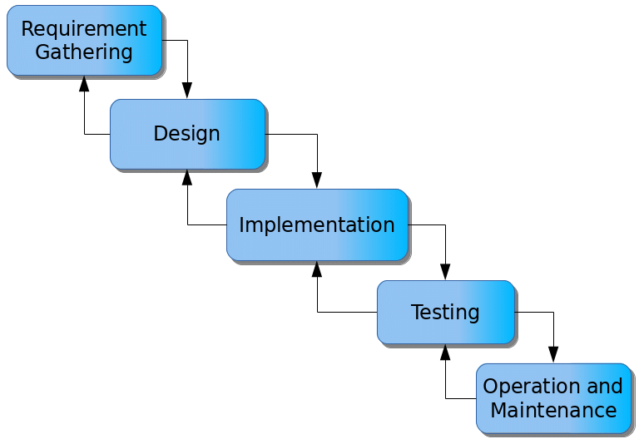

Figure 3.1: Waterfall model

**Requirement Stage:** During this stage, all possible system requirements were documented in a requirements document. This stage requires technical expertise and knowledge that personnel will use in operating the proposed application.

**Design Stage:** In this phase, high-level and low-level designs were prepared. The software design was created to verify the authenticity of the applications and ensure a seamless user experience.

**Development Stage:** In the Development phase, the software development team started coding and developing the software. This is the longest phase of the Waterfall Model as developers need more time to build the software. Once the development of the software is completed, the project is handed over to the testers.

**Testing Stage:** The software is developed and then tested to ensure it runs successfully. The researcher will ensure that the end-to-end software is complete and functional.

**Deployment Stage:** Once the software has been successfully tested, it is deployed to become live for real-time users. The deployment phase makes the application available to students and administrative staff.

**Maintenance Stage:** After deployment, the application enters the maintenance phase. Clients usually require a maintenance period of one or two years to address any bugs or to implement slightly enhanced features as needed.

## 3.5 Method of Data Collection

Data collection for the development of the **Computerized Testing Package for Primary School Pupils on Addition, Subtraction, Multiplication, and Division** system included both primary and secondary sources. Primary sources include direct interactions with stakeholders, such as interviews and surveys, to gather requirements and feedback. Secondary sources encompass existing literature, research, and relevant documentation related to online application systems and system development.

## 3.6 System Design

System design for the **Computerized Testing Package for Primary School Pupils on Addition, Subtraction, Multiplication, and Division** system involves defining the platform's architecture, modules, interfaces, and data structures to meet specified requirements. It entails the application of systems theory to product development, ensuring the alignment of design elements with the objectives and needs of the system.

## 3.6.1 Algorithm Diagram

Use case diagram: A use case diagram shows the system and the various ways that users interact with the system.

Start

Provide answer

View question

View Result

User

Stop

Figure 3.2: Use case diagram

**3.6.2 System Architecture**

Database MySQL

Apache Server

ARITHMETIC TESTING PACKAGE



Figure 3.3: System Architecture

## 3.6.3 Input and Output Design

## Input design

**CHOOSE AN OPERATION**

_

÷

+

×

Figure 3.4: Choose operation

## Input design

**Addition**

Enter your numbers (Level 3)

**ADDITION**

Number 1

Number 2

Number 3

Enter your numbers (Level 1)

**ADDITION**

Number 1

Number 2





Enter your numbers (Level 3)

**ADDITION**

Number 1

Number 2

Number 3

Number 4



Figure 3.5: Addition Solver

**Subtraction**

Enter your numbers (Level 3)

**SUBTRACTION**

Number 1

Number 2

Number 3

Enter your numbers (Level 1)

**SUBTRACTION**

Number 1

Number 2





Enter your numbers (Level 3)

**SUBTRACTION**

Number 1

Number 2

Number 3

Number 4



Figure 3.6: Addition Solver

**Multiplication**

Enter your numbers (Level 3)

**Multiplication**

Number 1

Number 2

Number 3

Enter your numbers (Level 1)

**Multiplication**

Number 1

Number 2





Enter your numbers (Level 3)

**Multiplication**

Number 1

Number 2

Number 3

Number 4



Figure 3.7: Addition Solver

**Division**

Enter your numbers (Level 3)

**DIVISION**

Number 1

Number 2

Number 3

Enter your numbers (Level 1)

**DIVISION**

Number 1

Number 2





Enter your numbers (Level 3)

**DIVISION**

Number 1

Number 2

Number 3

Number 4



Figure 3.8: Addition Solver

**Output design**

Step 1: Let's use these numbers: 5, 4

Multiply ✖️ 5 × 4 = 20

**🎉 Final Answer: 20.00**

Step 1: Let's use these numbers: 2, 4

Add ➕ 2 + 4 = 6

**🎉 Final Answer: 6.00**

Step 1: Let's use these numbers: 20, 4

Subtract ➖ 20 - 4 = 16

**🎉 Final Answer: 16.00**

Step 1: Let's use these numbers: 20, 4

Divide ➗ 20 ÷ 4 = 5

**🎉 Final Answer: 5.00**

Figure 3.9: Result Interface

## 3.7 System Requirements Specification

## 3.7.1 Hardware Requirements

The software to be design needs the following hardware for an effective operation of the newly designed system.

1. A system running on intel, P(R) duo core with higher processor
2. The-Random Access Memory (RAM) should be at least 512MB.
3. At least 20-GB hard disk.
4. A monitor.

## 3.7.2 Software Requirements

The software requirements include:

1. A window 7 or higher version of operating system.
2. Browser

## 3.7.3 Personnel Requirements

Any computer literate who has a technical knowhow of internet surfing can use the system because it is user friendly.

# CHAPTER FOUR

# RESULTS AND DISCUSSION

## 4.1 Introduction

This chapter presents the results obtained from the design and implementation of the package for testing primary school pupils on Arithmetic. It discusses the performance, usability, and accuracy of the system through various tests and evaluations. The chapter is structured to provide a comprehensive analysis of the results, starting with the welcome interface, followed by an examination of the system's functionality, user experience, and overall effectiveness.

## 4.2 Results

## 4.2.1 Welcome Interface

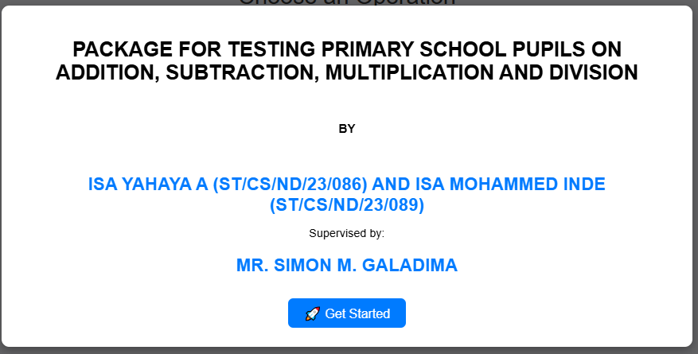

Figure 4.1: Welcome Interface

The above figure 4.1 shows the welcome page of the Package for testing primary school pupils on Arithmetic, the welcome page is the first page that displays on opening the program.

## 4.2.2 Tutorial Menu Interface

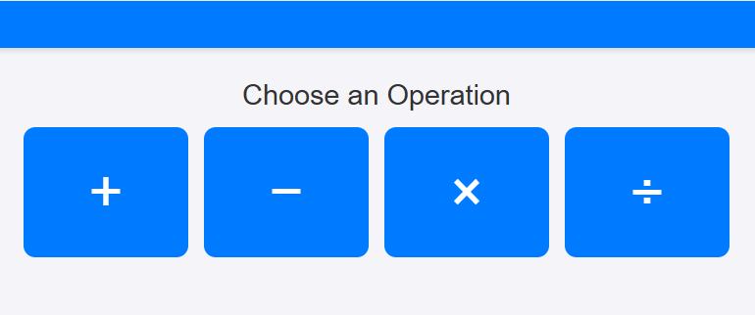

Figure 4.2: Choose Operation interface

Figure 4.2 above shows the system menu where the pupil chooses the arithmetic to learn Addition, Subtraction, multiplication, or division.

## 4.2.3 Calculation Interface

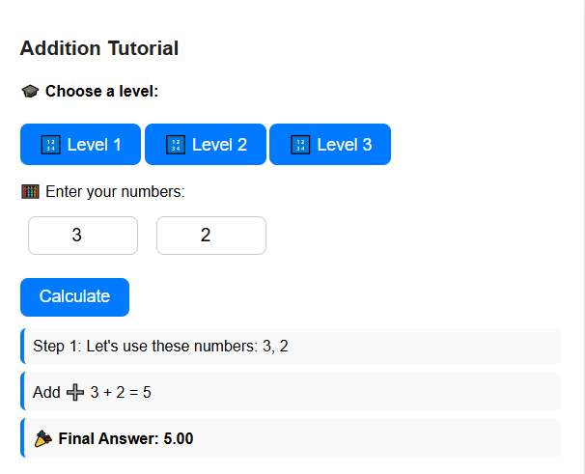

Figure 4.3: Result Interface

Figure 4.3 above shows the calculation and result interface with levels ranging from Level 1 to Level 3 depending on the arithmetic chosen for testing/practice.

## 4.2.4 Quiz Interface

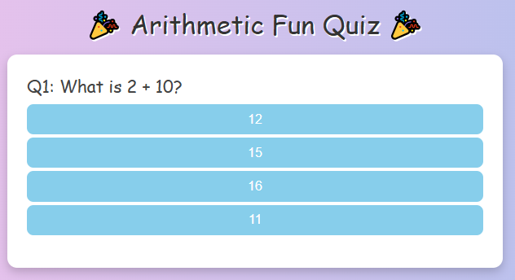

Figure 4.4: Quiz interface

Figure 4.4 shows the quiz interface of the program where a pupil can be tested on the arithmetic learned and scores awarded at the end.

## 4.2.5 Result Interface

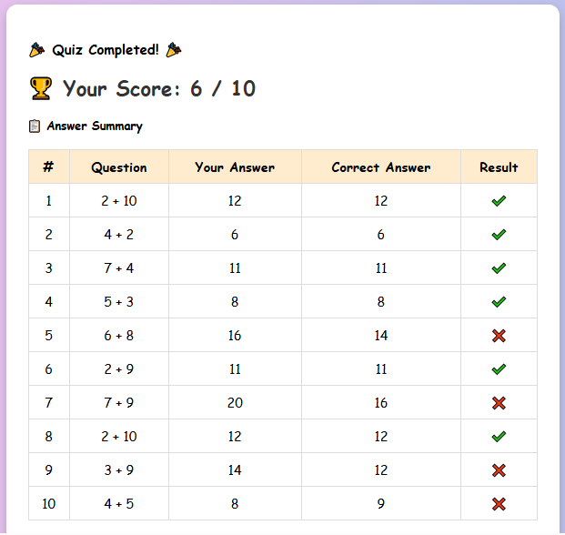

Figure 4.5: Result Interface

Figure 4.5 shows the result of the quiz take be the pupil showing the question, the answer provided by the pupil and the correct answer.

## 4.3 Discussion

The developed package for testing primary school pupils on arithmetic provides a user-friendly interface that facilitates both learning and assessment. As illustrated in Figure 4.1, the Welcome Page serves as the entry point of the program, offering a simple and engaging interface that immediately captures the pupil’s attention. This introductory page is essential for creating a welcoming learning environment, especially for young learners.

Moving forward, Figure 4.2.2 presents the System Menu, which allows pupils to choose from four fundamental arithmetic operations Addition, Subtraction, Multiplication, and Division. This menu-driven approach supports personalized learning, enabling users to focus on specific areas based on their needs or teacher’s instructions.

Figure 4.3 displays the Calculation and Result Interface, where pupils can practice arithmetic problems across three difficulty levels: Level 1 (Basic), Level 2 (Intermediate), and Level 3 (Advanced). This grading of difficulty ensures a progressive learning curve and caters to the varying competencies of pupils. The interface provides immediate feedback, helping pupils to understand their mistakes and reinforce learning through repetition and correction.

The Quiz Interface, as shown in Figure 4.4, is designed for testing pupils' understanding of the arithmetic concepts they have practiced. It presents random questions based on the selected arithmetic type and level, simulating an actual test environment. Upon completion of the quiz, the system evaluates the pupil’s performance and displays the score, which motivates learners and allows teachers or guardians to monitor progress.

Finally, Figure 4.5 shows the Quiz Result Page, which details the questions attempted, the pupil’s answers, and the correct answers. This feature enhances transparency and encourages self-assessment, enabling pupils to identify their strengths and areas needing improvement.

Overall, the system combines learning and assessment in a structured, interactive, and child-friendly manner. It promotes independent learning, continuous assessment, and skill mastery in basic arithmetic crucial for building a strong mathematical foundation at the primary level.

## 4.4 User manual

## 4.4.1 System Installation

The user manual is a clear and precise instruction on how a user can operate the propose system, without any stress and successful. The following steps required

1. Start or boot the computer form the hard disk
2. Double click on the folder that program is been stored in the desktop
3. Double click on the program and allow it to load gently
4. A welcome menu will be displayed where the user has options to select which operation to be performed.
5. To find information about player, select any name and search.
6. Click on exist on the welcome screen to exist from the program.

## 4.4.2 System Installation

The following are the necessary steps to take in order to use the system efficiently and effectively.

1. Load the url of the system <https://localhost/maths/> the welcome page will be displayed.
2. Click on the **Proceed** button to proceed to the main system.
3. If you created an account, provide your login details by entering your username and password.
4. Depending on the login details provided you will be automatically directed to the dashboard.
5. The various task that you can perform on the portal will be displayed on the sidebar of the dashboard.

# CHAPTER FIVE

# SUMMARY, CONCLUSION AND RECOMMENDATIONS

## 5.1 Summary

This project focused on the design and implementation of a computer-based package for testing primary school pupils on basic arithmetic operations. The primary aim was to create an interactive, engaging, and educational tool that supports both learning and assessment of fundamental arithmetic skills Addition, Subtraction, Multiplication, and Division.

The system was developed with a user-friendly interface to accommodate young learners. It features several modules including a Welcome Page, a Menu Interface for selecting arithmetic types, a Practice Interface with levels of difficulty, a Quiz Interface for testing knowledge, and a Result Interface that displays pupils' performance. The tiered levels in the practice module (Level 1 to Level 3) support progressive learning, while the quiz and result components enhance performance evaluation and feedback. Through this project, it has been demonstrated that integrating technology into early mathematics education can greatly improve engagement, understanding, and self-paced learning among pupils.

## 5.2 Conclusion

The computerized Arithmetic Operations Testing package for primary school pupils has proven to be a useful educational tool that addresses some of the challenges in traditional arithmetic teaching methods. By providing a structured and interactive environment for both practice and assessment, the system enhances the pupils’ learning experience, encourages independent study, and fosters better understanding of mathematical concepts.

Additionally, the immediate feedback mechanism embedded in the system helps to correct misconceptions, reinforce correct answers, and improve retention. Overall, the project has met its objectives by delivering a solution that is not only effective but also scalable and adaptable for use in various educational settings.

## 5.3 Recommendations

Based on the development and evaluation of this project, the following recommendations are made:

1. Schools should consider integrating such computer-based learning tools into their curriculum to supplement traditional teaching methods, especially in mathematics.
2. Future versions of the package could include more advanced topics and other subjects such as English, Science, or Social Studies to make it a more comprehensive learning platform.
3. To further enhance user engagement, the system could incorporate sounds, animations, and voice instructions that would aid pupils who are still learning to read.
4. A monitoring system can be added to allow teachers and parents to track the progress of each pupil, view reports, and offer targeted support.
5. Considering the widespread use of smartphones and tablets, adapting the application for mobile platforms (Android/iOS) would improve accessibility and usability.
6. The software should be regularly updated based on user feedback to ensure it remains relevant and effective.

# REFERENCES

Adekunle, A., & Nwosu, F. (2021). *Enhancing numeracy skills through interactive learning platforms*. Journal of Educational Technology, 18(2), 45–53.

Adebayo, S., & Musa, B. (2021). *Primary education challenges in Nigeria: A digital perspective*. Nigerian Journal of Pedagogy, 7(1), 33–41.

Adeyemi, M., & Bassey, U. (2023). *Mobile learning tools and their impact on mathematics comprehension*. African Journal of ICT in Education, 11(4), 77–89.

Ahmed, A., & Ojo, M. (2022). *Bridging the math gap: Instructional design for early learners*. Journal of Childhood Education Research, 9(2), 120–133.

Aliyu, M., & Haruna, I. (2022). *Strategies for engaging pupils with arithmetic using games and visual tools*. Nigerian Journal of Educational Studies, 6(3), 95–108.

Alabi, T., Adepoju, R., & Hassan, M. (2020). *Digital transformation in primary education in Sub-Saharan Africa*. Journal of ICT in Africa, 5(1), 28–39.

Aminu, R., & Obong, E. (2021). *Gamified learning and academic performance in mathematics*. International Journal of Primary Education Studies, 10(1), 56–64.

Bello, K., & Ogundele, A. (2021). *An empirical study on e-learning effectiveness in Nigerian primary schools*. Nigerian Journal of Instructional Media, 8(2), 91–100.

Chinedu, O., & Sunday, T. (2022). *Mathematics anxiety and technology-based learning among young pupils*. Journal of Educational Psychology in Africa, 4(2), 66–79.

Ede, T., & Olatunji, B. (2021). *Pupils' attitudes toward digital math tutorials in public schools*. Educational Innovation Review, 9(3), 88–97.

Ekong, J., & James, T. (2021). *Educational media integration in rural Nigerian schools*. African Review of Educational Research, 12(1), 103–115.

Eze, N., & Ibrahim, O. (2023). *Digital platforms for arithmetic education in under-resourced communities*. International Journal of Basic Education, 7(2), 49–60.

Idowu, F., & Chukwu, A. (2022). *Interactive learning systems and academic success: A Nigerian case study*. West African Journal of Learning Sciences, 5(4), 110–122.

Ibrahim, A., & Adeyemi, S. (2021). *The effect of visual aids on arithmetic learning*. Journal of Early Grade Mathematics, 3(1), 23–35.

Ibrahim, A., & Salami, K. (2022). *Comparative analysis of mobile math applications in Nigerian schools*. Educational Computing Research Journal, 6(2), 70–82.

James, T., & Bello, K. (2023). *Digital tools for arithmetic learning among primary pupils: A case study in Yola*. African Journal of Education and ICT, 14(1), 55–67.

Johnson, M., & Matthews, J. (2020). *Best practices in developing numeracy software for children*. Journal of EdTech and Innovation, 10(2), 88–102.

Johnson, T., & Bello, K. (2020). *Enhancing pupil engagement through mobile learning*. Journal of Digital Education Strategies, 5(3), 44–59.

Ladipo, K., Aremu, D., & Ogunleye, A. (2023). *Content adaptation in educational software for local learners*. Nigerian Educational Technology Journal, 13(1), 101–113.

Lawal, A., & Danjuma, M. (2021). *Multimedia and interactive math tutorials for early education*. Journal of Digital Instructional Tools, 8(4), 87–95.

Liu, W., Zhang, Y., & Chen, L. (2023). *Cognitive benefits of arithmetic games in early education*. International Journal of Child Learning Technologies, 9(2), 19–32.

National Council of Teachers of Mathematics (NCTM). (2021). *Principles and standards for school mathematics*. NCTM Press.

Nwosu, F., & Ajayi, O. (2023). *Evaluating primary school arithmetic performance through digital interventions*. Journal of Educational Assessment and Improvement, 12(3), 61–74.

Okafor, T., & Nwachukwu, P. (2022). *Mathematics software adoption in Nigeria’s rural schools*. Journal of African Education Systems, 11(2), 74–85.

Okonkwo, E., & Ibrahim, T. (2022). *Computer-based math programs: A Nigerian perspective*. African Journal of Educational Software, 4(1), 47–55.

Okoro, C., & James, T. (2022). *Digital literacy among Nigerian primary teachers*. Journal of Educational Practices, 8(2), 93–108.

Okoro, C., & Musa, B. (2022). *Teaching arithmetic through visual aids and gamification*. Nigerian Journal of Pedagogical Research, 6(1), 77–90.

Onuoha, C., & Garba, M. (2022). *Performance evaluation of arithmetic tutorial software in selected primary schools*. International Journal of Instructional Design, 9(2), 58–70.

Oluwaseun, G., & Nnaji, C. (2023). *Pedagogical effectiveness of math learning software in Nigeria*. African Journal of Instructional Design, 7(4), 89–101.

Stewart, L. (2015). *Teaching mathematics visually: Modern strategies for young learners*. Cambridge University Press.

Tijani, R., & Nwachukwu, J. (2022). *Learning outcomes of primary pupils using arithmetic tutorials*. Journal of Digital Learning in Africa, 5(2), 90–99.

UNESCO. (2023). *Guidelines on digital learning for primary education*. <https://unesco.org/publications/digital-learning-guidelines>

Yusuf, R., Bello, S., & Hassan, U. (2023). *Evaluation of computer-based arithmetic packages in Nigerian classrooms*. Journal of Instructional Systems in Africa, 10(3), 132–144.

# APPENDIX A

Welcome interface

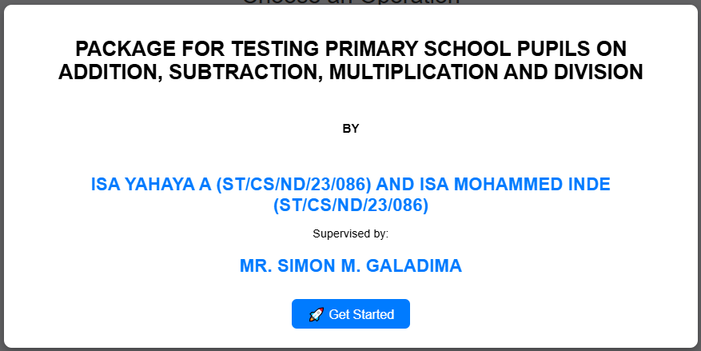

Calculation Interface



Quiz Interface



Tutorial Menu Interface



Result Interface



# APPENDIX B

**PROGRAM CODE**

<!DOCTYPE html>

<html lang="en">

<head>

<meta charset="UTF-8" />

<meta name="viewport" content="width=device-width, initial-scale=1.0"/>

<title>Arithmetic Tutorial and Quiz</title>

</head>

<body>

<!-- Navigation Bar -->

<nav class="navbar">

<div class="nav-brand">🧮 My Arithmetic Tutor</div>

<ul class="nav-links">

<li><a href="#" onclick="goHome()">🏠 Home</a></li>

<li><a href="#" onclick="goHome()">📘 Tutorial</a></li>

<li><a href="maths.html">🧪 Quiz</a></li>

</ul>

</nav>

<!-- Welcome Modal -->

<div id="welcomeModal" class="modal">

<div class="modal-content">

<h1>PACKAGE FOR TESTING PRIMARY SCHOOL PUPILS ON ADDITION, SUBTRACTION, MULTIPLICATION AND DIVISION</h1> <br>

<h3>BY</h3><br>

<h2>ISA YAHAYA A (ST/CS/ND/23/086) AND ISA MOHAMMED INDE (ST/CS/ND/23/086)</h2>

<p> Supervised by: <br>

<h2>MR. SIMON M. GALADIMA</h2>

<button onclick="closeModal()">🚀 Get Started</button>

</div>

</div>

<div class="title">Choose an Operation</div>

<!-- Operation Selection -->

<div class="operations-container" id="operationMenu">

<div class="card" onclick="showTutorial('+')">+</div>

<div class="card" onclick="showTutorial('-')">−</div>

<div class="card" onclick="showTutorial('*')">×</div>

<div class="card" onclick="showTutorial('/')">÷</div>

</div>

<!-- Tutorial Section -->

<div class="container" id="tutorialSection">

<h3 id="tutorialTitle"></h3>

<p><strong>🎓 Choose a level:</strong></p>

<div>

<button onclick="setLevel(2)">🔢 Level 1</button>

<button onclick="setLevel(3)">🔢 Level 2</button>

<button onclick="setLevel(4)">🔢 Level 3</button>

</div>

<p style="margin-top: 20px;">🧮 Enter your numbers:</p>

<div class="input-pair" id="inputContainer">

<input type="number" class="number-input" placeholder="Number 1" />

<input type="number" class="number-input" placeholder="Number 2" />

</div>

<button onclick="showSteps()">Calculate</button>

<div id="stepExplanation" style="margin-top: 15px;"></div>

<button onclick="startQuiz()">🎮 Start Quiz</button>

</div>

<!-- Quiz Section -->

<div class="container" id="quiz">

<p id="question"></p>

<input type="number" id="answer" placeholder="?" />

<br />

<button onclick="checkAnswer()">Submit</button>

<p id="result"></p>

<button onclick="generateQuestion()">Next Question</button>

</div>

<script>

let num1, num2, correctAnswer, operator = null;

let level = 2; // Default Level 1

function setLevel(n) {

level = n;

const container = document.getElementById("inputContainer");

container.innerHTML = ''; // Clear previous inputs

for (let i = 0; i < n; i++) {

const input = document.createElement("input");

input.type = "number";

input.className = "number-input";

input.placeholder = `Number ${i + 1}`;

input.style.margin = "5px";

container.appendChild(input);

}

}

function speak(text) {

const utterance = new SpeechSynthesisUtterance(text);

utterance.lang = 'en-US';

utterance.rate = 0.9;

speechSynthesis.speak(utterance);

}

function showTutorial(selectedOperator) {

operator = selectedOperator;

document.getElementById("operationMenu").style.display = "none";

document.getElementById("tutorialSection").style.display = "block";

const titles = {

'+': 'Addition Tutorial',

'-': 'Subtraction Tutorial',

'*': 'Multiplication Tutorial',

'/': 'Division Tutorial'

};

document.getElementById("tutorialTitle").innerText = titles[operator];

document.getElementById("stepExplanation").innerHTML = '';

}

function showSteps() {

const inputs = document.querySelectorAll(".number-input");

const numbers = Array.from(inputs).map(input => parseFloat(input.value));

const stepBox = document.getElementById("stepExplanation");

stepBox.innerHTML = '';

if (numbers.some(n => isNaN(n))) {

alert("⚠️ Please enter all the numbers.");

return;

}

correctAnswer = eval(num1 + operator + num2);

const questionText = `What is ${num1} ${operator} ${num2}?`;

document.getElementById("question").innerText = questionText;

document.getElementById("result").innerText = "";

document.getElementById("answer").value = "";

const spokenOperator = {

'+': 'plus', '-': 'minus', '*': 'times', '/': 'divided by'

};

speak(`What is ${num1} ${spokenOperator[operator]} ${num2}`);

}

function checkAnswer() {

const userAnswer = parseFloat(document.getElementById("answer").value);

const resultEl = document.getElementById("result");

if (userAnswer === correctAnswer) {

const msg = `Correct! The answer is ${correctAnswer}. Well done!`;

resultEl.innerText = msg;

resultEl.style.color = "green";

speak(msg);

} else {

const msg = `Wrong! The correct answer is ${correctAnswer}.`;

resultEl.innerText = msg;

resultEl.style.color = "red";

speak(msg);

}

}

function goHome() {

document.getElementById("operationMenu").style.display = "grid";

document.getElementById("tutorialSection").style.display = "none";

document.getElementById("quiz").style.display = "none";

}

// Show welcome modal on load

window.onload = function () {

document.getElementById("welcomeModal").style.display = "flex";

};

// Close the modal

function closeModal() {

document.getElementById("welcomeModal").style.display = "none";

}

</script>

</body>

</html>